**TnP Technical Task: Innerve’18 website**

***Note: This website is just a sample layout for Innerve’18. It contains Lorem Ipsum content and images are taken from other college’s fests in a very random manner. Also, certain fun elements are added in order to showcase vast HTML properties and Bootstrap features. This website is fully responsive.***

Following are the screenshots of the Innerve website along with the features of each section:

**FRONTEND:**

Frontend is built using HTML5, CSS3, Bootstrap4, PHP and JavaScript. ScrollReveal is used in the website.

1. Navigation bar is fixed and particle.js is used in the background.

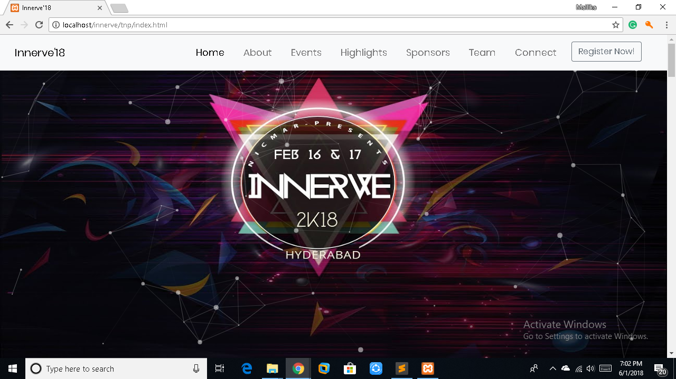

1. Navigation bar links change to bold font (scrollspy is used here) and a ‘return to top’ button appears in the bottom right corner.

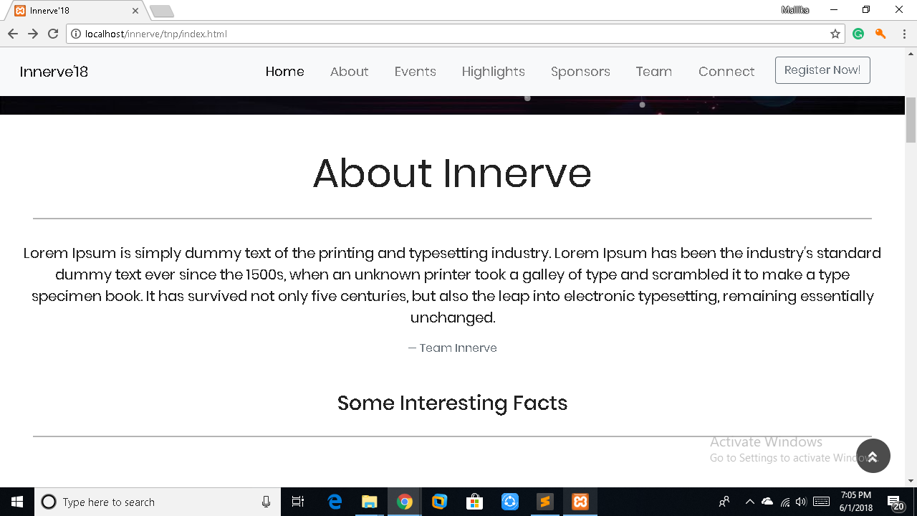

1. Countup.js is used here.

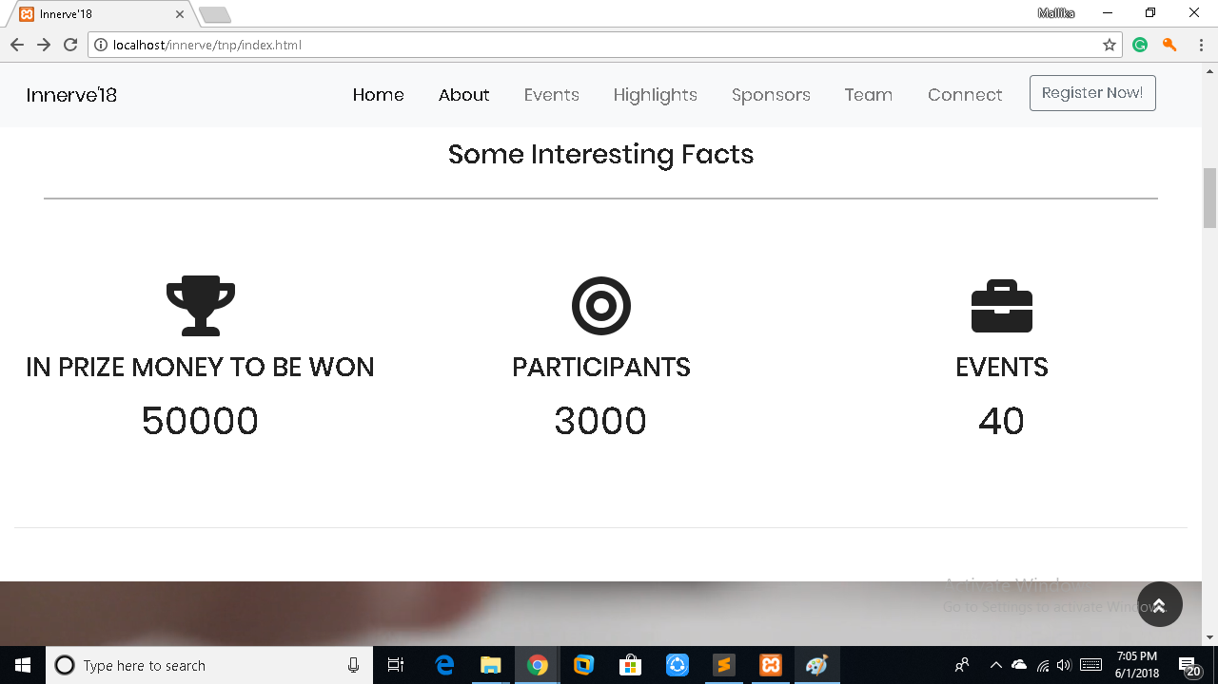

1. Video carousel is used.



1. Bootstrap image grid system can be seen.

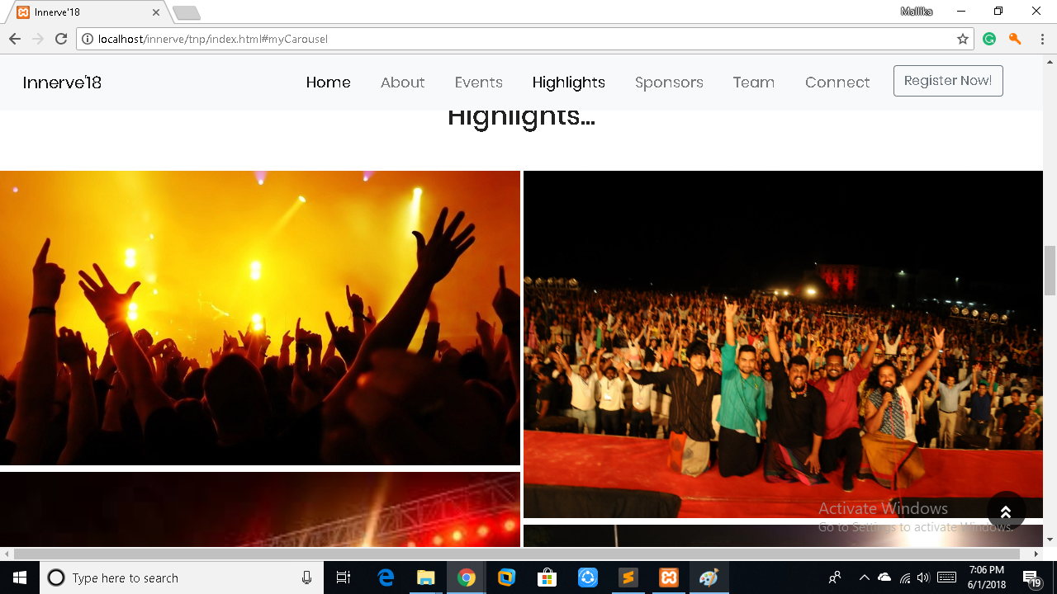

1. Hidden gifs, appear on click of a button. Also, parallax scrolling can be seen here.

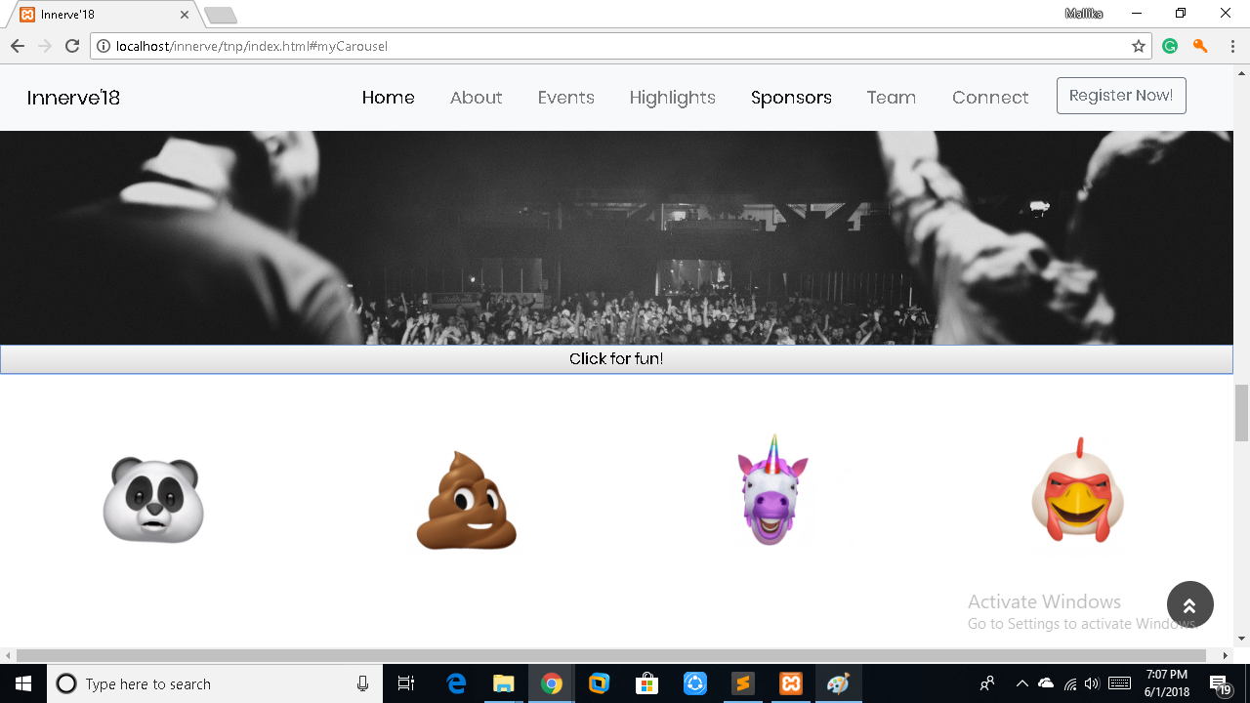

1. Very basic team section.

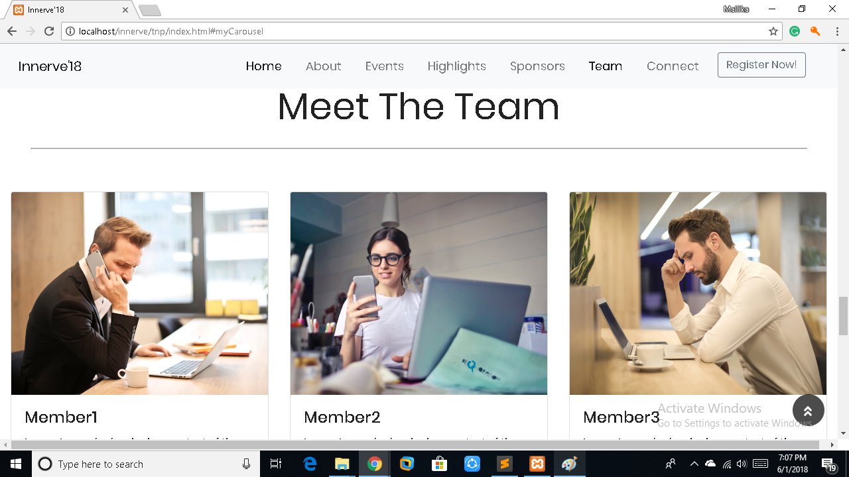

1. Social icons section and contact information.

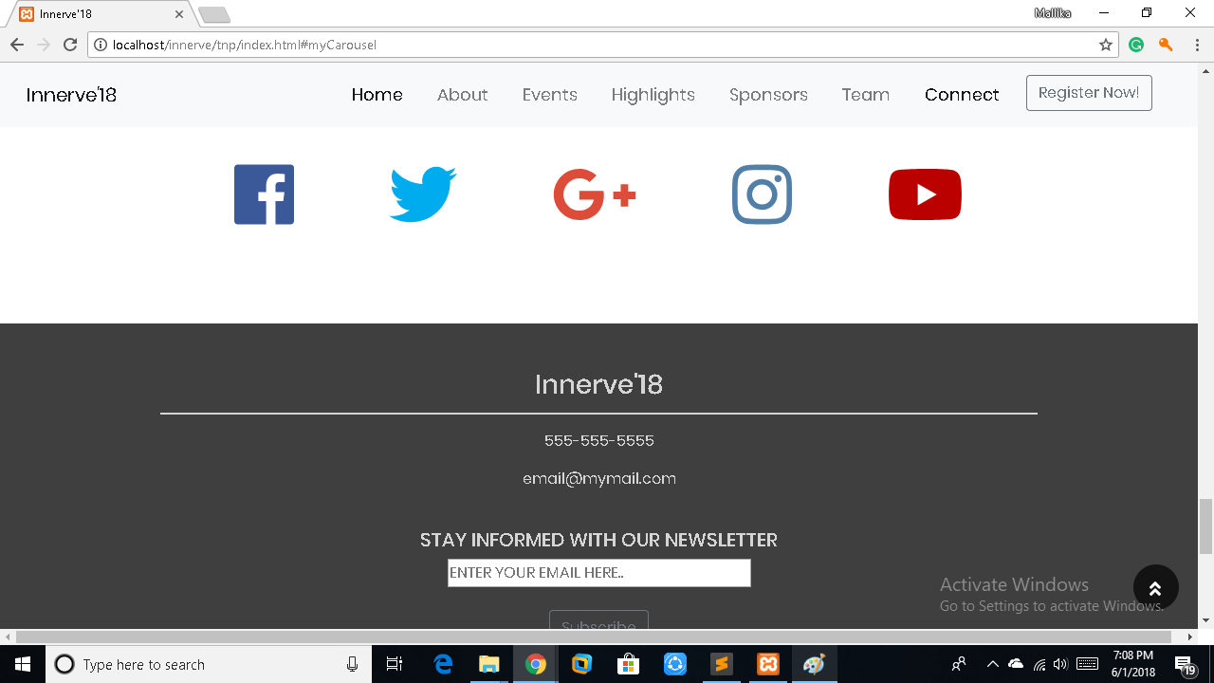

**BACKEND:**

The next two images are ‘Registration page’ and ‘Login page’. Database connectivity is done using PHP and XAMPP server with complete JavaScript validations.

Database name: innerve

Table name: Registration

Attributes:

Registration_Id-Primary Key

Name-VARCHAR

Email-Varchar (UNIQUE)

University-VARCHAR

Password(VARCHAR *encrypted*)

Phone_Number -BIG INT

